# City of Alameda

# Emergency Housing for the Homeless Community Meeting

# *November 29, 2021*

SUMMARY NOTES

## Introduction

The City of Alameda’s Community Development Department sponsored a community listening session regarding the Emergency Housing for the Homeless Program on Monday, November 29, 2021, from 6:00 p.m. to 8:00 p.m. at the Albert H. DeWitt Officers' Club. The purpose of the meeting was to provide the community an opportunity to ask questions and share their concerns regarding the program.

City Public Information Officer Sarah Henry opened the meeting, welcoming community members to the listening session meeting and introducing City staff and a representative from Bay Area Community Services (BACS), the program provider. She introduced the meeting moderator Lou Hexter of MIG, Inc., who reviewed the purpose and agenda for the evening.

The City’s Community Development Department staff provided a short overview of the program. Jonathan Russell, representing BACS, gave an overview of the organization’s history, the services and support programs they offer, and what the program in Alameda would be like.The meeting was then opened for public questions and comments using submitted comments cards. Ana Padilla of MIG recorded these on a wallgraphic; a photo reproduction is provided at the end of this report.

This summary organizes written and graphically recorded questions and comments that arose in the meeting into themes.

## Public Comments

Throughout the meeting, several key themes emerged regarding the overall program. These are listed below.

*Process Concerns*:

* Lack of transparent communication and information
* Legal qualification
* Lack of community consent
* Questions regarding redress for problems and issues
* Budget of the program
* Want more opportunity to speak

*Neighborhood Concerns:*

* Security
* Feeling unsafe
* Inappropriate behavior
* Lack of background checks for program participants
* Trash
* Quality and suitability of housing (lead paint, neglected repairs)
* High density (11 people to a unit)

*Questions*

* How and when will this be done?
* What are the motivations?
* Whom do we call when there are concerns/Immediate issues?
* What services will be offered to people in the homes?
* Why not use the barracks?

## Comment Cards

The following table provides a transcript of the speaker cards turned in at the meeting.

| **Name** | **Address** | **City** | **From the Big Whites nbhd.?** | **Email** | **Topic/ Comment/ Question** |
| --- | --- | --- | --- | --- | --- |
| Brian Verhalen | 2835 San Pedro Rd | Alameda | X |  | Several   1. Resident treatment 2. Qualifications of shelter |
| Caeris Thomas |  |  | X |  | We are concerned that with low- barrier entry, the guy who tried to kick in doors with children home, and the guy who stole a neighbor’s truck and injected drugs in it with the encampments could be our next door neighbors. Elaborate clearly if/ what background checks will be done. |
| Elana Mingo | 2600 Lemoore Rd. #B | Alameda | Nextdoor to location | elanamingo@gmail.com | I have 3 people with autoimmune diseases & Covid. My house will be directly next door. health & my family’s health is at risk. I have a teenager & two small kids. How are you vetting people who are potentially dangerous? My family matters. Please act like we do. This is too small paper for everything I have to say. |
| Acton Mingo | 2600 Lemoore Rd. | Alameda |  | amjinfantry@gmail.com | There’s lots of families including mine which are planning to have people moved too this want be a dangerous and scary decision for the people of my neighborhood. |
| Alan Tubbs | 2805 Seattle Road | Alameda | X |  | Resident comment – 16 year resident |
| Bruce Langley | 1523 Schiller St Apt C | Alameda |  | brucelangley@gmail.com | Need for emergency housing in Alameda |
| Patricia Moore | 2811 Barbers Pt Rd | Alameda | X | patmas@sonic.net |  |
| Todd Hings | 2775 Peal Harbor Rd | Alameda | X | Tfhines66@gmail.com | * Not here to learn. Here to prevent. * If the houses being offered for shelter are “Suitable for habitatation,” what does that have say about the homes we pay $30 -$40k annually to rent? * This not safe for our children |
| Shelly Sheehan |  |  | X | sheehan.shelby@gmail.com | 1. Zoning codes – compliance – permit 2. HAB Letter – Letter 3. CEQA Complainance letter 4. Alternative for 125,000   No evidence the project is legal -> late does not meet L-B-E entine |
| Mike Pouncy | (Do not publish) 2750 Orion St. Alameda CA 94501 | Alameda | X | mpouncy@gmail.com | 1. Why is this pushed through with no general plan or community info? 2. How will new temp residents access food, safety, & mental health Services? 3. Megan’s law issues & questions of identification 4. Would it make more sense to rent properties & work for services? Only ~30ish spots? 5. What is one system of redress if things aren’t working out? |
| Savanna Cheer | 1495Santa Clarita | Alameda |  | savanna.cheer@gmail.com |  |
| Stephanie Chenard | 2775 Pearl Harbor Rd | Alameda | X | Stephanie.chenard@presidio.edu | * Over-concentration of services at Alameda Point – Clustering * How will BACS address staffing issues and program ownership? |
| Craig Mich |  | Alameda | X | craig@khyberinvestments.com | Long List |
| Gwyn J. Anson | 2835 San Diego | Alemeda | X | Gjohnson002@comcast.net | Various Concerns |
| Amy Benjamin | 2750 Orion | Alameda | In a ranch next to big white |  | Why was I made aware of this on Facebook? What kind of background check do residents go through? After the 1 meal / day where will people get resources? Is this sober housing? If not, and where will they be able to imbibe? |
| Jonathan Lynch | 2835 San Pedro Rd | Alameda | x | Jon99L@gmail.com | How is it safe to have 11 people in a house?  What system do you have in place to address grievances?  How do you propose to keep the area safe? |
| Amos White | 310 Westline Drive | Alameda |  |  |  |
| Verginia (Ginger) Alexander | 2850 Pearl Harbor Rd | Alameda | X | tomyginger@earthli | As new housing on the base becomes available, will it all be dedicated to interim housing for the unhoused? |
| Cheryl Principate | 536 Kings Road | Alameda | X Bus, Neighbor Tower Ave | Cheryl @ceraunavolta.us | California is in a state of emergency – so we could be requesting a national guard response. Might we have a space for a tent city with guarding for safety & all so with gov’t support. |
| Jack Mingo | 2825 Newport Rd | Alameda | x |  | Why not use the former barracks across the street? Already furnished. |
| Alan Tubbs |  |  | X |  |  |
| Hela C. |  |  | What is it |  | I do not support this homeless emergency program. I have various reasons written in notes on my phone. |
| Jenice Anderson |  | Alameda |  | Jjma44@yahoo.com | People seeking out services are not doing it to commit crime in your neighborhoods. |
| Tony Barulic | 2845 San Pabloo Rd | Alameda | x | barulic@gmail.com | What is plan for dealing with existing neglected properties? |
| Doug Biggs | 677 N. Rangsa |  |  |  |  |
| Shelby Sheehan |  |  |  |  | Look at the Main St suburban zoning restrictions  By right  CEQA Historic Zones  Low Density |
| Cray Miott |  | Alameda | X | craig@khyberinvestments.com |  |
| Rebecca Caplan | 2840 Pearl Harbor Rd |  | x |  | What about encampment |
| Mike Pouncy | n/a | On previous card | x |  | Community response is a part of program success |
| Bod Sprelding | 2855 Pearl Harbor Rd | Alameda | X | honobob@yahoo.com | 1. Did the city consider other lower risk locations like other barracks/buildings on base? If yes, when & which ? If no, why not? 2. Why did the city think making this decision without consulting the residents was the right way to handle this? 3. Why are there no city decision makers here to explain their decisions and answer our questions? |
| Councilmember Tony Daysog |  |  |  |  |  |
| Councilmember Trish Herrera- Spencer |  |  |  |  |  |

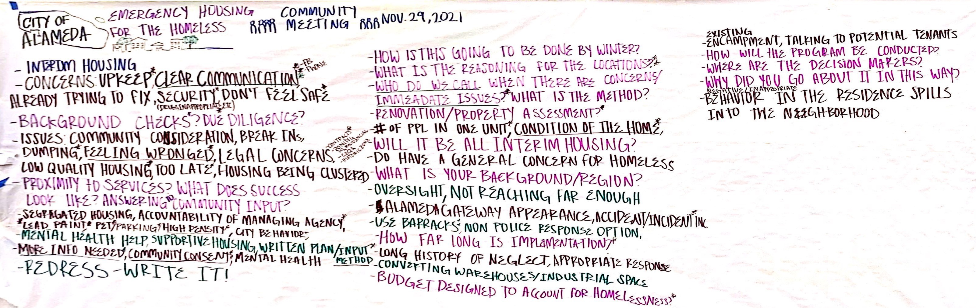

**Emergecny Housing for the Homeless  
CITY OF ALAMEDA**

**Wallgraphic**

*November 29, 2021*

MIG Logo *Prepared by:*

## City of Alameda

## Emergency Housing for the Homeless

## 11-29-2021

**Wallgraphic**

－Interum housing

－Concerns: Upkeep,* Clear Communication** (Facebook, Phone), Already trying to fix, Security** (Drygs, Inappropriate behavior, Etc.), Don’t feel safe*

－ Background Checks? Due diligence?

－Issues: Community Consideration, Break ins, Dumping*, Feeling wronged,* Legal concerns (Contracts,* Zoning M1/ Residential, CEQA, Historic zone), Low quality housing,* Too late,* housing being cluster

－Proximity to services? What does success look like? Answering to community input?

－Segregated housing, accountability of managing agency,* Lead paint **, Pet*/ Parking*/ High Density*/ City Behavior

－Mental Health help, supportive housing, written plan/ input method*

－More info needed*, Community Consent**, Mental Health

－Redress – Write It!

－How is this going to be done by winter?

－What is the reasoning for the locations?

－Who do we call when there are concerns/ Immeadate Issues?* What is the method?

－Renovation/ Property assessment?*

－＃of ppl in one unit*, condition of ths home*

－Will it be all Interim Housing?

－Do have a general concern for homeless

－What is your background/ region?

－Oversight, not reaching far enough

－Alameda gateway appearance, accident/ incident inc.

－Long history of neglect, appropriate response

－Converting warehouses/ industrial space

－Budget designed to account for homelessness?*

－Existing Encampment, talking to potential tenants

－How will the program be conducted?

－Where are the decision makers?

－Why did you go about it in this way?

－Negative/ Inappropriate behavior in the residence spills into the neighborhood