Alameda Countywide  Clean Water Program  A Consortium of Local Agencies | November 2015 | Good Housekeeping Practices
Stormwater runoff from industrial and commercial businesses is one of the major contributors to urban runoff pollution. Automotive fluids, paints, solvents, food wastes, | In response to recent Federal and State water quality regulations and requirements, municipalities in Alameda County have joined to form the Alameda Countywide Clean Water Program (ACCWP).  The ACCWP consists of the Cities of Alameda, Albany, Berkeley, Dublin, Emeryville, Fremont, Hayward, Livermore, Newark, Oakland, Piedmont, Pleasanton, San Leandro, Union City, Alameda County, the Alameda County Flood Control and Water Conservation District, and Zone 7 of the District.  The Goal of the ACCWP is to control discharges of pollutants to municipal storm drain systems (and local creeks and the San Francisco Bay). The ACCWP encourages using Best Management Practices to effectively eliminate illegal discharges and connections.  The Storm Drain System was built to collect and transport rain to prevent flooding in urban areas. Anything that flows or is discharged into the storm drain system goes directly into local creeks or San Francisco Bay without any treatment.  The Sanitary Sewer System collects and transports sanitary wastes from interior building plumbing systems to the wastewater treatment plant where the wastewater is treated.  Best Management Practices (BMPs) are methods and practices such as good housekeeping, spill prevention, or treatment measures to prevent or minimize pollutant discharges to municipal storm drain systems.  Illegal Discharges or Illicit Connections discharge non-storm water to municipal storm drain systems and contribute to water pollution.  Urban Runoff is rain and any other water that passes through and out of developed areas (streets, parking lots, roof tops, etc.) into the storm drain system and eventually to creeks and other waters. |  | Keeping pollutants out of our storm drain system protects our local creeks, reservoirs, and the San Francisco Bay. Materials swept, blown, or washed into the storm drains end up in these open waters where they degrade water quality and harm aquatic life. In general, wastewater discharged to the storm drains is illegal.  In addition to reviewing their own practices, municipalities participating in the Alameda Countywide Clean Water Program (ACCWP) have instituted a business education campaign and inspection program. Inspectors work with contractors and businesses to identify and control potential discharge of pollutants to the storm drain system. Property and business owners are responsible for their contractors’ practices.  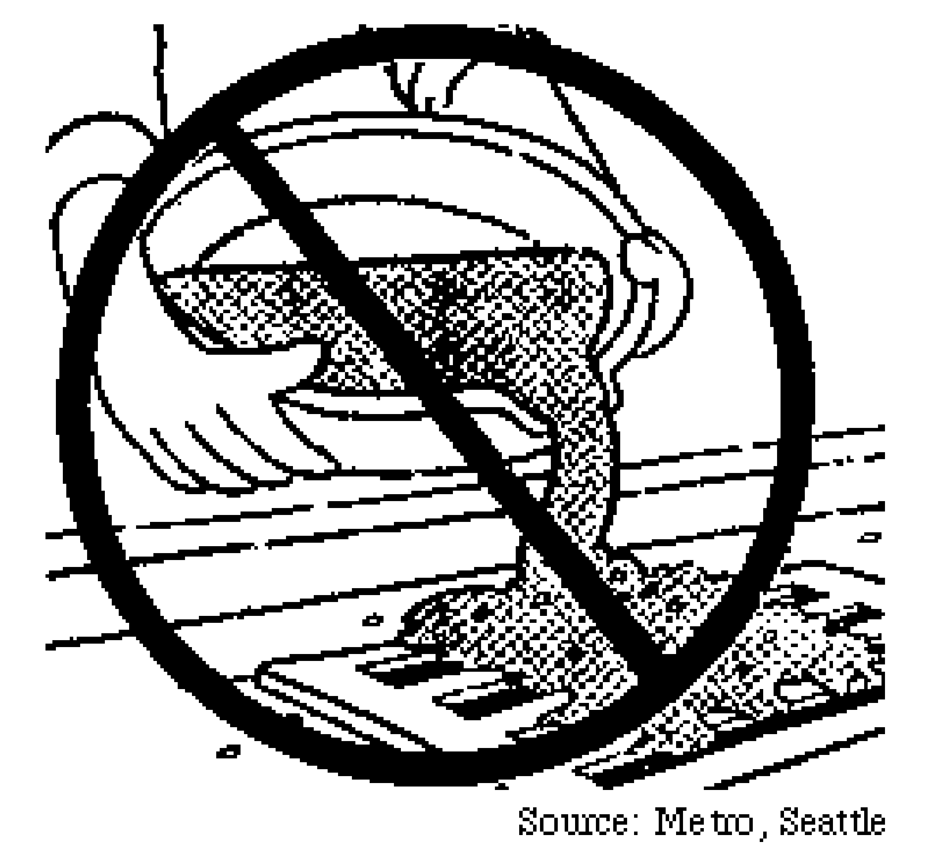  grease, pesticides, herbicides, litter, cement and yard wastes are some of the pollutants that get into the storm drain system.  All businesses can apply good housekeeping practices in their daily activities to reduce or eliminate their contribution to stormwater pollution. The table on the reverse side of this page identifies some of these good housekeeping practices.  If you need additional information concerning stormwater pollution and its prevention contact the City of Alameda program representative at 510-747-7930, or the Alameda County Clean Water Program at www.cleanwaterprogram.org .

Best Management Practices for Good Housekeeping
 | Follow these BMPs to control pollutant discharges. The objectives are: 1) to keep pollutants from contacting rain, and 2) to keep pollutants from being dumped or poured into the storm drains. The goal is "only rain in the storm drain."
 | Activities | Best Management Practices
 | Pavement Cleaning | - Sweep parking lots and other paved areas regularly to remove debris. Dispose of debris in the garbage.  - If outdoor pavement cleaning is required, collect wash water and dispose in indoor sinks or drains for discharge to the sanitary sewer. Do not let any debris, wastes or washwater into the street or storm drain.
 | Litter/Spill Control | - Provide an adequate number of trash receptacles for your customers and employees. This helps keep trash from overflowing the receptacles.  - Pick up litter and other wastes daily from outside areas including storm drain inlet grates.  - Use spot cleaning methods to control leaks and spills on pavement or in loading dock areas. Do not wash spills down into street or storm drains.
 | Waste Disposal* | - Inspect dumpsters and other waste containers periodically. Repair or replace leaky dumpsters and containers.  - Cover dumpsters and other waste containers.  - Never dispose of waste products in storm drain inlets.  - Recycle wastes or dispose properly.
 | Materials Storage* | - Store materials such as grease, paints, detergents, metals, and raw materials in appropriate, labeled containers.  - Make sure all outdoor storage containers have lids, and that the lids are adequately closed.  - Store stockpiled materials inside a building, under a roof, or covered with a tarp to prevent contact with rain.
 | Training | - Train employees regularly on good housekeeping practices.  - Assign a person to be responsible for effective implementation of BMPs.
 | Equipment/Vehicle Cleaning | - Maintain equipment and vehicles regularly. Check for and fix leaks.  - Use drip pans to collect leaks or spills during maintenance activities.  - Wash equipment/vehicles in a designated and/or covered area where the wash water is collected to be recycled or discharged to the sanitary sewer. Contact your local wastewater treatment agency.
 | Some Facilities will require structural control BMPs if simpler operational BMPs are not adequate for keeping pollutant discharges from the storm drains.
* Hazardous materials must comply with hazardous materials storage and disposal requirements.

